**Jobs in IT**

Reading activity

The impact of artificial intelligence (AI) on the workplace

Key Terms:

* AI: Artificial Intelligence. It is an emergent technology that have become in a powerful tool to increase the productivity. AI is based y complex algorithms and programming methods which results in machines that can learn and evolve.
* Automate: Is the process of convert a repetitive activity in an automatic process that don’t need the human supervision.
* Predictive Analytics: Is the act of analyze and give sense to a huge quantity of data.
* Reskilling and upskilling: With the AI arriving, jobs must be redesigned and adapted to this new reality, although human job will be gradually replaced by AI, more work opportunities raise, people need to learn and reinforce their skills to be ready for this new job way.

Understanding Sentences

1. The assembly line in a car factory is a good example of automate. Production lines can be optimized with automated processes.
2. All the industries eventually will have to apply the Reskilling and upskilling to guarantee that workers have the same or better lifestyle.

Potential benefits and challenges of AI

Although some threats about the rising of the AI seems real, in fact benefits are more than this. Startin with people that could see how their jobs can be better and have more time to share with their families. Another benefit can be seen in industries, where we could see more efficient processes better quality and less production times.

The Challenges about the use of AI is focused in the management that governments or private industries could do. Their own interest could cause a waving of illegal or non-ethical practices that could impact in people even causing vulnerating their primary rights.

Third session

Video about IT

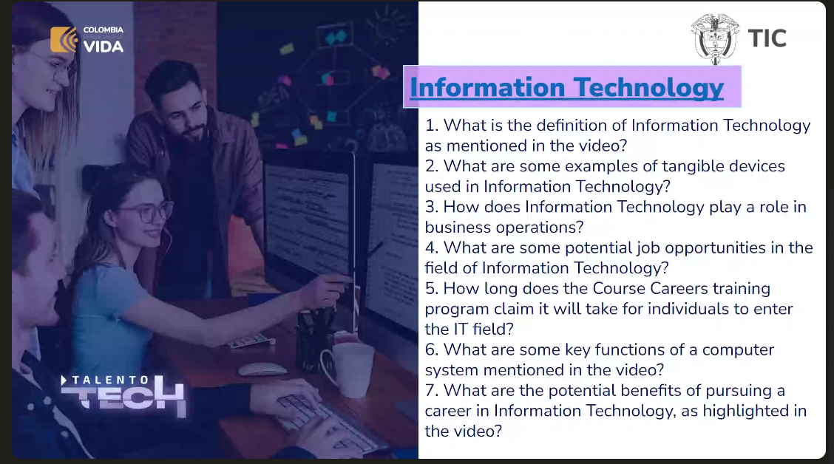

1. Use of computers and technologic devices for use and handling of data
2. Tangible is the hardware
3. Use of the data analysis to take the better decisions about businesses, real time information.
4. IT have many areas to develop good skills and get a job with a good salary.
5. 6 months
6. Salary, big demand

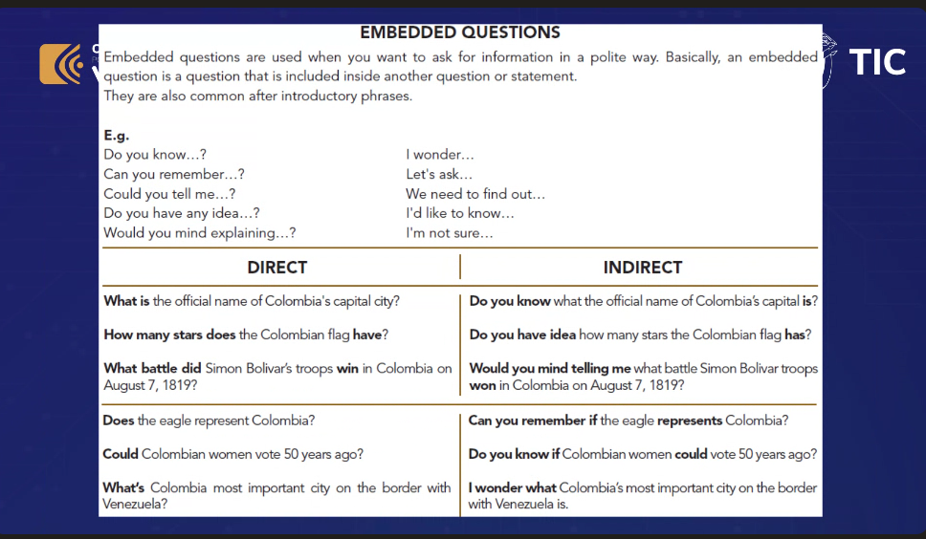

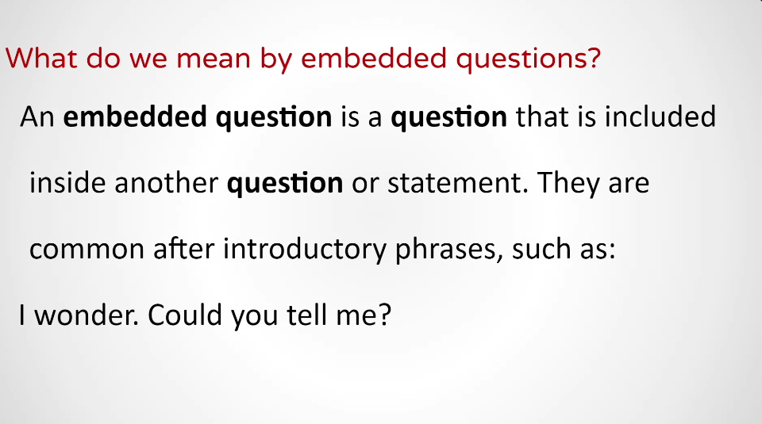

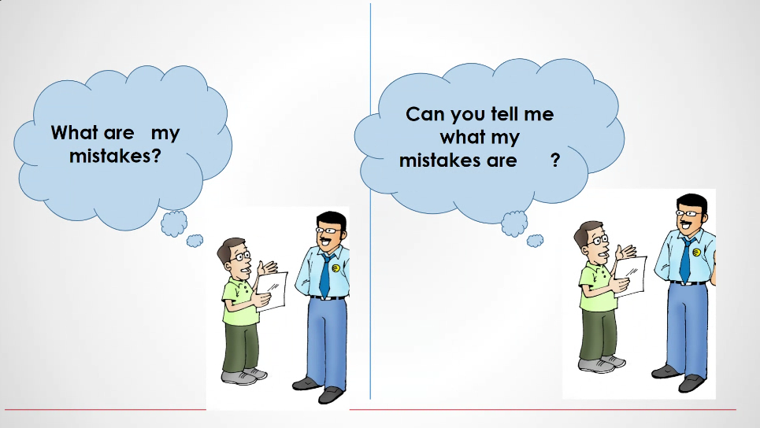

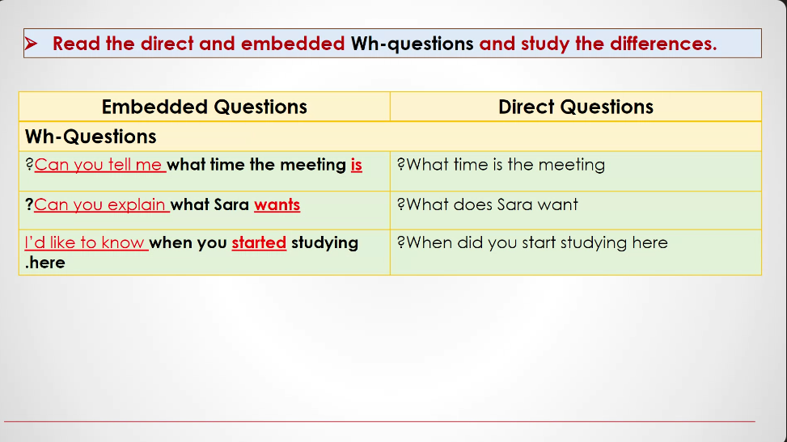

Costumer service

Use of the data

Tangible and untangible